23 January 2020  Private and Confidential |  | Pharmacy Department  Farnham Road Hospital  Guildford  GU2 7LX  T: 01483 443717  E: pharmacy@sabp.nhs.uk

Parent information – Change from Concerta XL to Delmosart XL

Introduction
The purpose of this leaflet is to explain the change from using a brand of slow release methylphenidate tablets called Concerta XL, to a different brand named Delmosart XL. GPs are also going to be switching some of their patients to this new brand of methylphenidate tablets.

What is changing?
Your child has currently been taking the Concerta XL brand of tablets and is now to be prescribed Delmosart XL tablets instead.
Delmosart XL tablets and Concerta XL tablets have the same type of medicine in them called Methylphenidate which is prescribed for treating Attention Deficit Hyperactivity Disorder (ADHD). These tablets have different brand names as they are made by different companies.
The methylphenidate is released slowly from these tablets during the day to ensure the medicine is effective for approximately 12 hours. The beneficial effects of the Delmosart XL tablets will therefore be the same as when your child was taking the Concerta XL tablets.

Why is this change happening?
This change is happening because Delmosart XL tablets are less expensive than Concerta XL tablets. By using Delmosart XL tablets, the money freed up can be invested into other NHS services while the treatment of ADHD will be just as good.

What do I have to do?
You do not need to do anything. The prescription for the new Delmosart XL tablets will continue to be prescribed by your child’s doctor or nurse as before. There will be no change to the way that the prescription can be dispensed. The medication is taken at exactly the same time of day as before.

What are the benefits for my child?
There are no additional benefits. However, as mentioned above, the money freed up would be used for other NHS services; this will be a benefit for everyone who uses the NHS.

What if I am unhappy with the change?
Please contact your child’s ADHD specialist doctor or nurse to discuss your concerns, they will be happy to discuss them with you.

What do Delmosart XL tablets look like?

All of the different strength tablets are about the same size – they are 12mm long and just under 7mm wide.

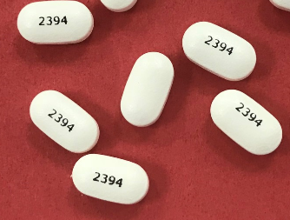

Where can I find more information?
If you have any further questions please ask your child’s ADHD specialist doctor or nurse, or your local pharmacy.

Information about methylphenidate is also available from the www.medicinesforchildren.org.uk website, and from www.choiceandmedication.org/sabp.

